INDUSTRIAL MACHINE RELIABILITY
& MRO SPEND ANALYTICS REPORT
A Data-Driven Assessment of Maintenance Spend, Asset Reliability
and Predictive Condition Signals Across 3 Plants
Prepared for: Plant Operations & Maintenance Leadership
Prepared by: Data Analytics & Business Intelligence Team
Analysis Period: 03 January 2022 – 01 January 2025
Report Date: 25 July 2026
Dataset: synthetic_industrial_machine_data.csv | 219,000 records | 10 assets | 3 plants

1. Executive Summary
This report presents a comprehensive, end-to-end analysis of three years of maintenance, repair and operations (MRO) transaction data across 10 assets in 3 manufacturing plants (Pune, Chennai, Dharuhera), covering 219,000 daily sensor-and-spend records from 3 January 2022 to 1 January 2025. The objective is to translate raw operational data into actionable insight on spend efficiency, machine reliability, and early-warning condition signals for predictive maintenance planning.

Key Findings at a Glance
Metric | Value
Total MRO Spend (3 years) | ₹1,33,40,945 (₹133.4 Lakh)
Total Parts Issued | 26,378 units across 20,953 issue transactions
Overall Breakdown Rate | 9.88% of all machine-days (21,636 of 219,000)
Highest-Spend Plant | Pune (PUN-01) — ₹52.4 Lakh (39.3% of total)
Highest Breakdown-Rate Plant | Dharuhera (DHR-03) — 11.00%
Highest-Risk Machine Type | Hydraulic Press — 11.32% breakdown rate
Top Spend Category | Bearings — ₹32.6 Lakh (24.4% of spend)
Strongest Breakdown Predictor | Machine Load % (correlation r = 0.10, +6.3% higher during breakdown)

Overall, spend and breakdown activity are broadly stable month-on-month with no runaway cost trend, but reliability is uneven across plants, machine types and individual assets. Hydraulic Presses and Screw Compressors break down more often than other machine classes, Critical (A) assets fail 82% more often than Routine (C) assets, and elevated load percentage is the clearest operating-condition signal that precedes a breakdown. Section 6 translates these findings into prioritised recommendations.

2. Dataset Overview & Data Quality
The dataset combines daily MRO parts-issue transactions with real-time machine condition sensors, structured as one row per asset per day.
Attribute | Detail
Records | 219,000 rows × 22 columns
Time span | 3 Jan 2022 – 1 Jan 2025 (1,094 days / ~36 months)
Assets tracked | 10 (AST-1041, 1042, 2017, 2031, 3008, 3019, 4055, 4061, 5003, 5007)
Plants | 3 — PUN-01 (Pune, 4 assets), CHN-02 (Chennai, 3 assets), DHR-03 (Dharuhera, 3 assets)
Machine types | 5 — CNC Lathe, Hydraulic Press, Belt Conveyor, Screw Compressor, EOT Crane
Unique spare parts | 20 SKUs across 9 part families
Missing values | Only in 'wo_type' (work-order type), populated exclusively on breakdown/PM days — expected, not a data quality defect
Duplicate rows | None detected
Range checks | All sensor values fall within physically plausible industrial ranges; no negative costs or quantities

Data quality is high: every field is fully populated except wo_type, which is null on the ~80% of asset-days with no work order raised — this is structurally correct, not missing data. Numeric ranges (temperatures 43.5–88.4°C, vibration 0.4–13.3 mm/s, oil pressure 3.3–7.4 bar) are consistent with rotating industrial equipment and show no outlier corruption. The dataset is fit for the analysis performed below.

3. Financial / Spend Analysis

3.1 Monthly Spend & Breakdown Trend
Monthly MRO spend has ranged between roughly ₹2.6 Lakh and ₹4.7 Lakh, tracking closely with the monthly count of breakdown events — confirming that breakdown-driven (reactive) work orders are a material cost driver, not just planned maintenance.
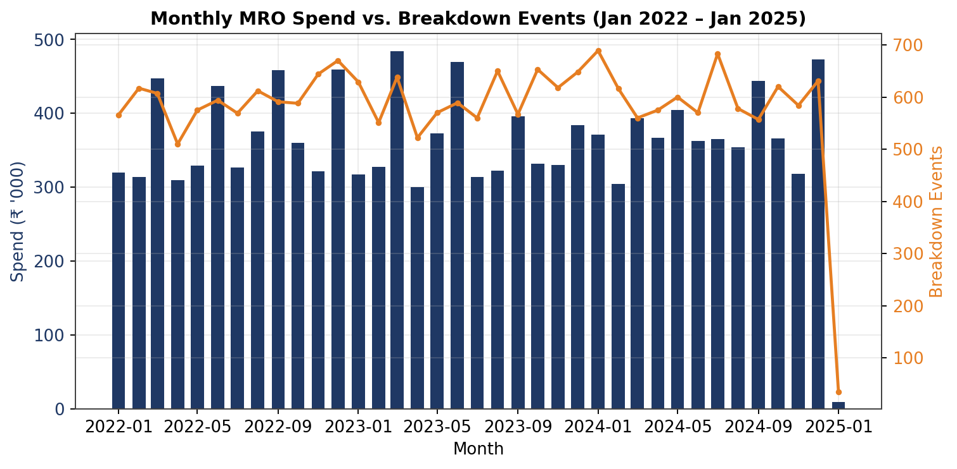
Figure 1: Monthly MRO spend (bars, left axis) plotted against monthly breakdown events (line, right axis).

3.2 Spend by Plant
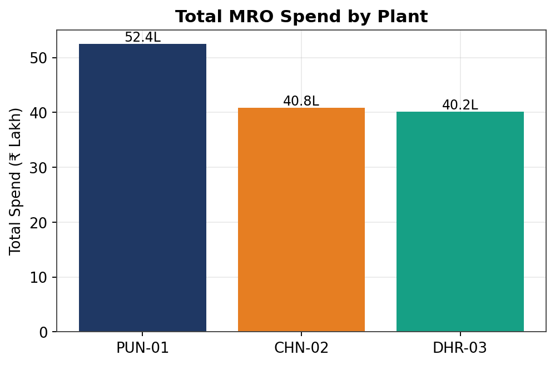
Figure 2: Total three-year MRO spend by plant.
Plant | Total Spend (₹) | Assets | Breakdown Rate
PUN-01 (Pune) | 52,44,949 | 4 | 9.55%
CHN-02 (Chennai) | 40,80,828 | 3 | 9.21%
DHR-03 (Dharuhera) | 40,15,168 | 3 | 11.00%

Pune leads in absolute spend simply because it operates the most assets (4 vs 3), but on a per-asset basis Dharuhera is the least reliable plant, with a breakdown rate almost 2 points higher than Chennai despite lower total spend — indicating Dharuhera's issue is reliability, not under-investment in parts.

3.3 Spend by Part Family
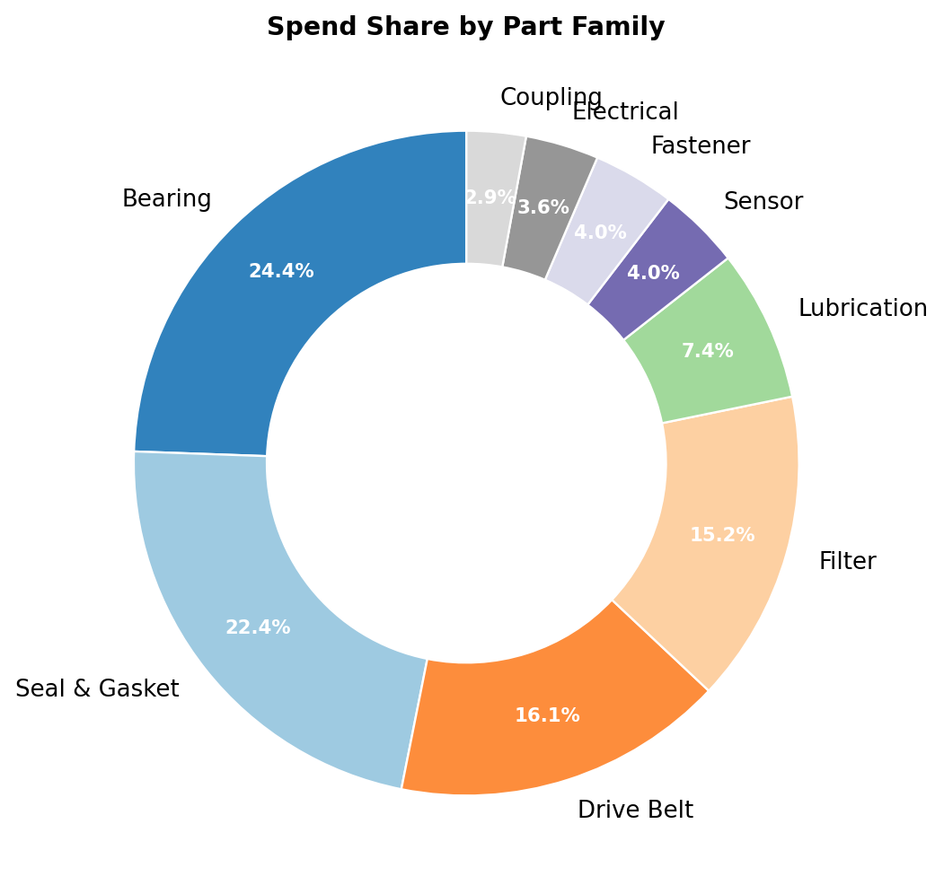
Figure 3: Share of total spend by spare-part family.
Part Family | Total Spend (₹) | % of Total | Qty Issued
Bearing | 32,60,200 | 24.4% | 2,276
Seal & Gasket | 29,92,129 | 22.4% | 2,391
Drive Belt | 21,51,850 | 16.1% | 3,773
Filter | 20,30,440 | 15.2% | 2,997
Lubrication | 9,83,586 | 7.4% | 5,769
Sensor | 5,36,300 | 4.0% | 598
Fastener | 5,27,190 | 4.0% | 7,702
Electrical | 4,75,290 | 3.6% | 359
Coupling | 3,83,960 | 2.9% | 513

Bearings and seals/gaskets together account for nearly half (46.8%) of all MRO spend, making them the natural focus for cost-reduction and vendor-negotiation initiatives, and for reliability-centred maintenance (RCM) review.

3.4 Top 10 Parts by Spend
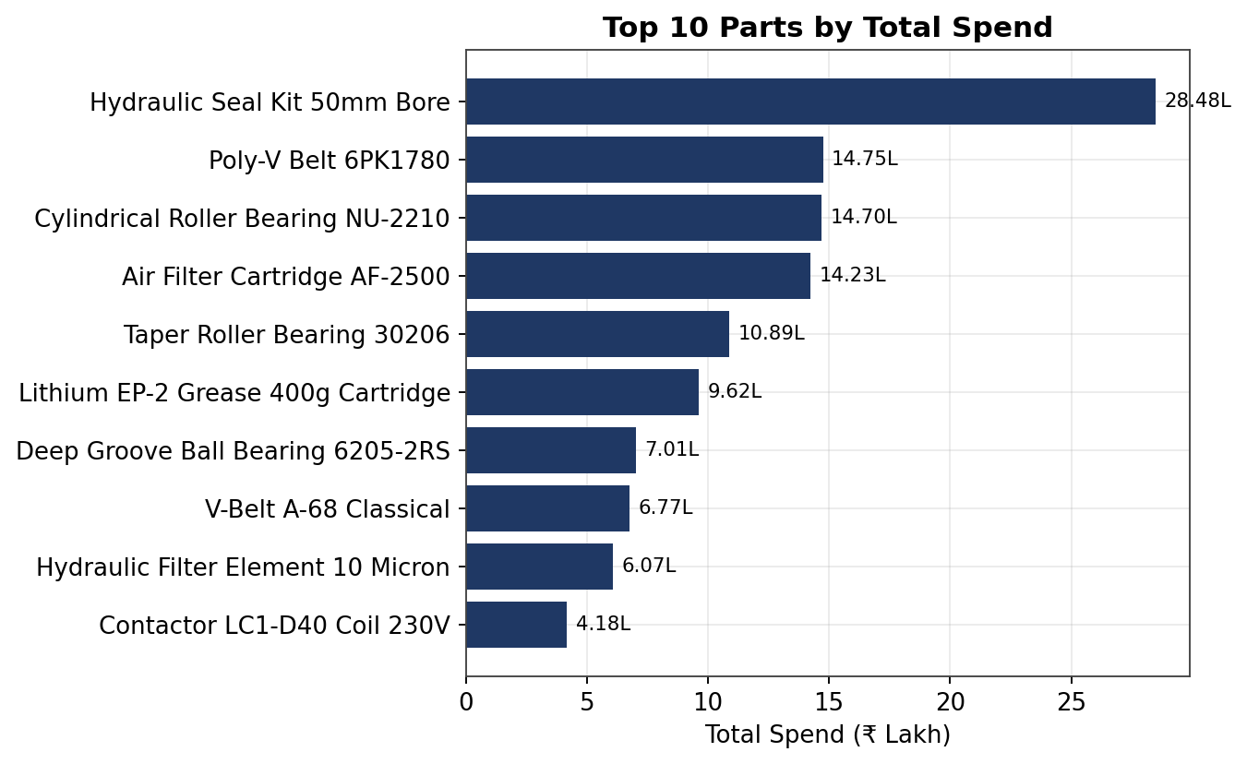
Figure 4: The ten highest-spend individual part numbers over the analysis period.
A single SKU — the Hydraulic Seal Kit 50mm Bore (MRO-20031) — accounts for ₹28.5 Lakh, or 21.3% of all spend, on just 890 units issued (average cost ₹3,200/unit). This part alone warrants a dedicated reliability investigation and supplier cost review, given its outsized share of the maintenance budget.

4. Reliability / Breakdown Analysis

4.1 Breakdown Rate by Machine Type
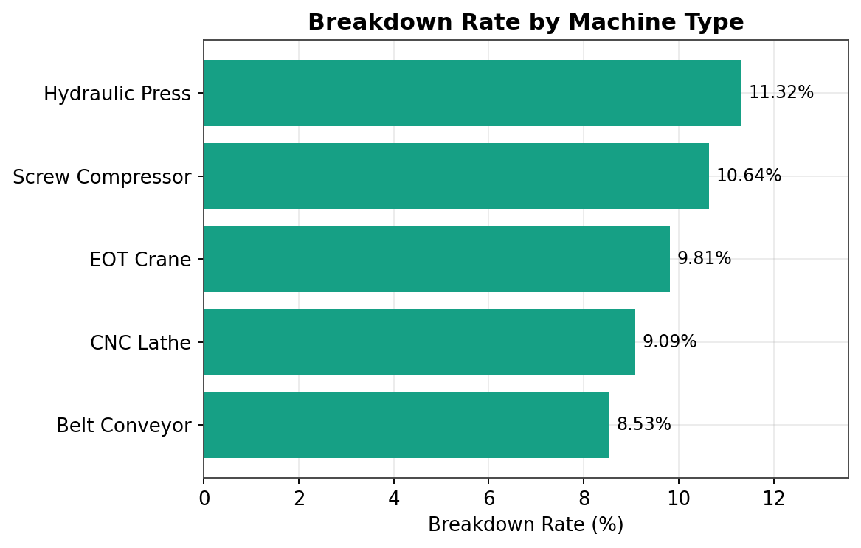
Figure 5: Percentage of asset-days ending in a breakdown, by machine type.
Machine Type | Breakdown Rate | Total Spend (₹)
Hydraulic Press | 11.32% | 26,32,803
Screw Compressor | 10.64% | 27,14,335
EOT Crane | 9.81% | 26,42,723
CNC Lathe | 9.09% | 26,05,562
Belt Conveyor | 8.53% | 27,45,522

Hydraulic Presses fail most often (11.32%) despite having similar spend to other classes — this points to a reliability gap rather than a maintenance-budget gap, and is the strongest candidate for root-cause failure analysis or a condition-based maintenance pilot.

4.2 Breakdown Rate & Spend by Asset Criticality
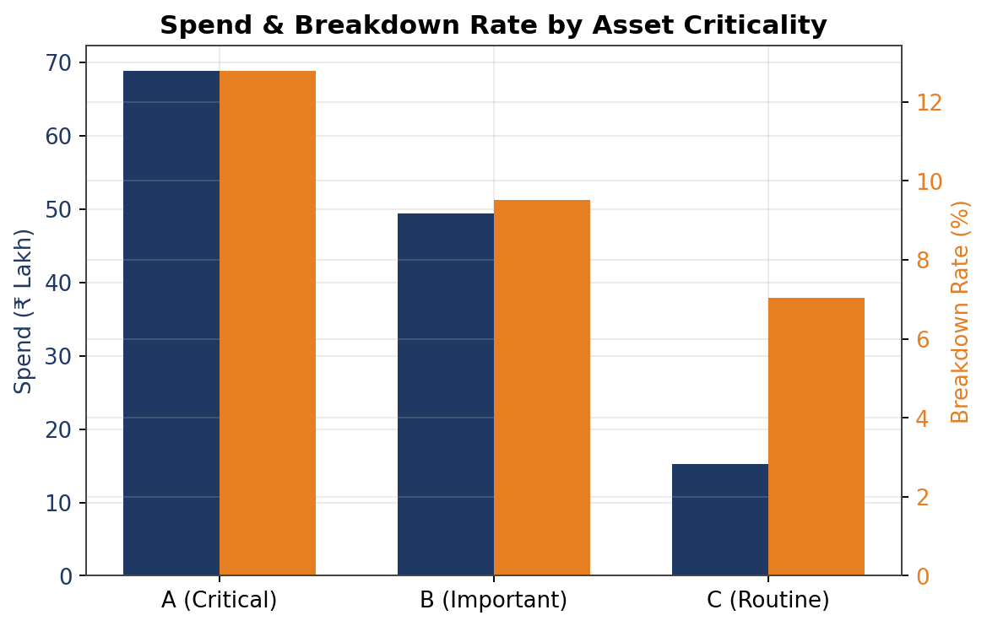
Figure 6: Spend (bars, left axis) and breakdown rate (bars, right axis) by criticality class.
Criticality | Breakdown Rate | Total Spend (₹) | Interpretation
A — Critical | 12.79% | 68,87,100 | Highest risk & highest spend — as expected for critical assets, but rate is a concern
B — Important | 9.51% | 49,33,805 | Moderate risk
C — Routine | 7.04% | 15,20,040 | Lowest risk, lowest spend

Critical (A) assets break down 82% more often than Routine (C) assets (12.79% vs 7.04%). While elevated attention to critical assets is expected, a failure rate above 1-in-8 asset-days for the most critical equipment class represents meaningful unplanned-downtime risk and should be the top priority for reliability investment.

4.3 Asset-Level Breakdown Ranking
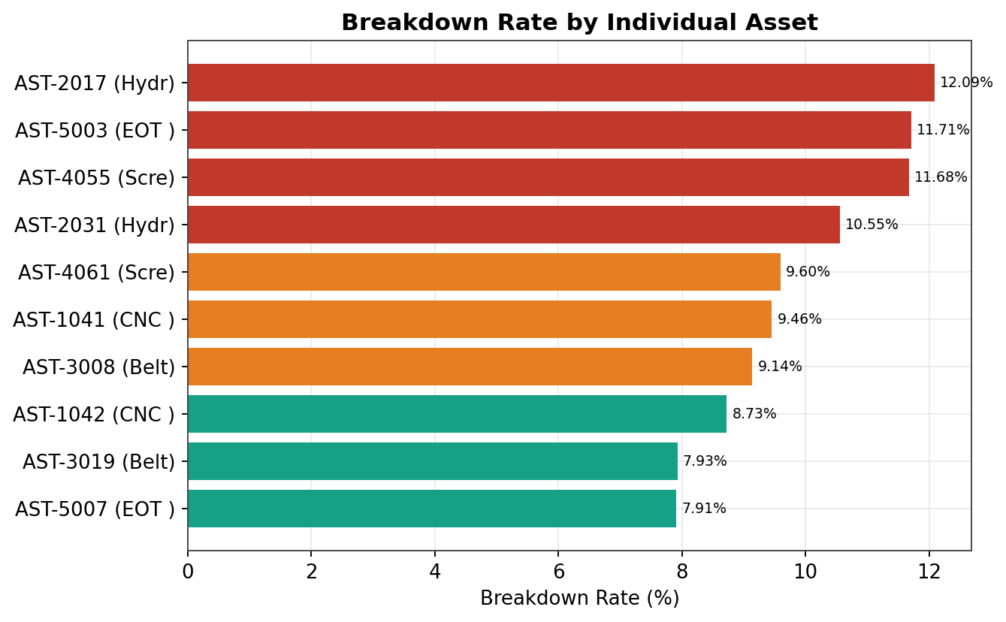
Figure 7: Breakdown rate for each of the 10 tracked assets (red = high risk >10%, orange = moderate 9–10%, teal = lower risk).
Three assets — AST-2017 (Hydraulic Press, Pune, 12.09%), AST-5003 (EOT Crane, Dharuhera, 11.71%) and AST-4055 (Screw Compressor, Dharuhera, 11.68%) — are the least reliable machines in the fleet and are recommended as the first candidates for a targeted reliability improvement or predictive-maintenance pilot.

5. Condition Monitoring & Predictive Signal Analysis

5.1 Sensor Behaviour: Breakdown vs. Normal Operation
Comparing mean sensor readings on breakdown days against normal-operation days reveals which condition signals shift meaningfully ahead of or during a failure event.
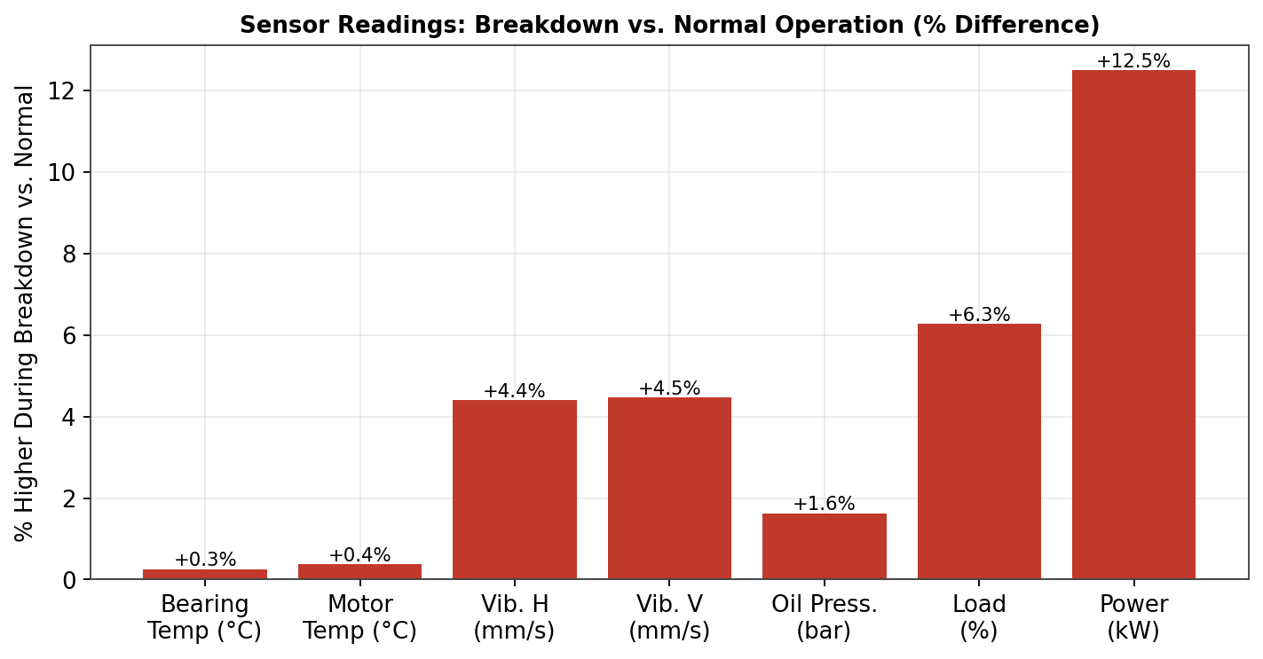
Figure 8: Percentage difference in mean sensor reading during breakdown events vs. normal operation.
Sensor | Normal (mean) | Breakdown (mean) | Difference
Load % | 67.92% | 72.18% | +6.3%
Power Consumption (kW) | 26.13 | 29.40 | +12.5%
Vibration – Horizontal (mm/s) | 3.85 | 4.02 | +4.4%
Vibration – Vertical (mm/s) | 2.89 | 3.02 | +4.5%
Oil Pressure (bar) | 5.00 | 5.08 | +1.6%
Motor Temperature (°C) | 71.06 | 71.33 | +0.4%
Shaft RPM | 1550.7 | 1580.4 | +1.9%
Bearing Temperature (°C) | 65.08 | 65.25 | +0.3%

Power consumption and load percentage show the largest and most consistent uplift during breakdown periods, while bearing and motor temperature are comparatively flat. This suggests that electrical/mechanical loading stress, rather than thermal drift, is the more reliable early-warning signal in this fleet.

5.2 Load Distribution: Normal vs. Breakdown
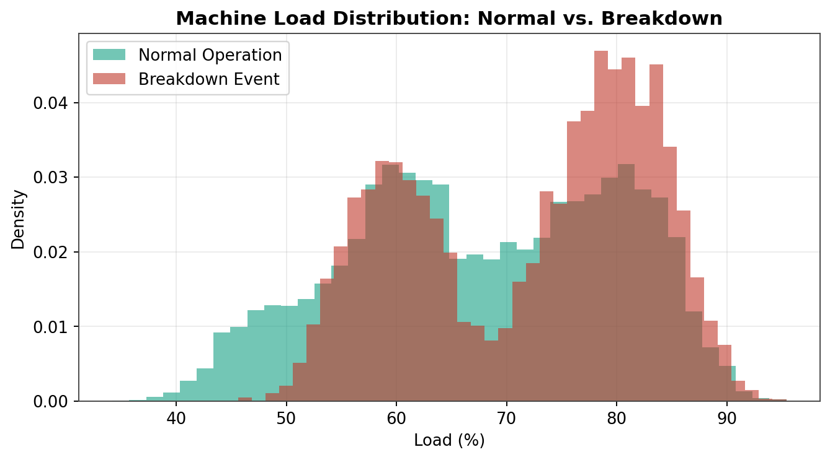
Figure 9: Distribution of machine load (%) comparing normal operation against breakdown events.
The breakdown-day load distribution is visibly shifted to the right, with a heavier concentration above 75% load. This supports using a load-percentage threshold (e.g., sustained operation above ~80%) as a practical trigger for maintenance alerts.

5.3 Correlation Analysis
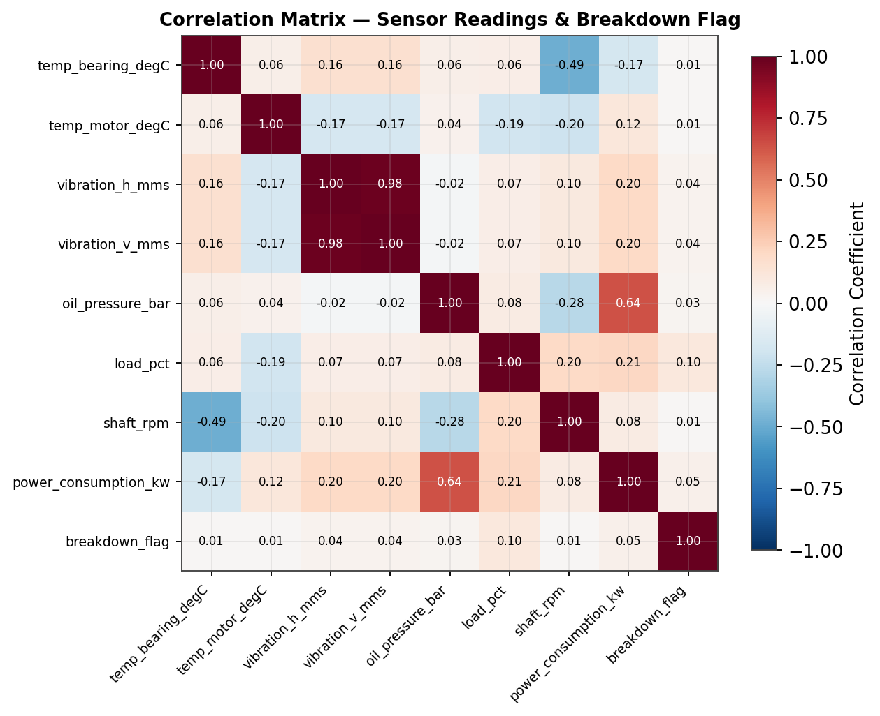
Figure 10: Pearson correlation matrix across all condition-monitoring sensors and the breakdown flag.
Correlations between individual sensors and the breakdown flag are all positive but modest in isolation (load % r = 0.10 is the strongest), which is typical for this type of operational data — breakdown risk here is driven by a combination of conditions rather than any single sensor crossing a hard limit. This favours a multi-variate early-warning model (e.g., logistic regression or gradient boosting on load %, power, and vibration together) over a single-threshold alarm.

6. Key Insights & Recommendations

6.1 Summary of Insights
- Spend and breakdown volumes move together month-to-month — reactive (breakdown) work orders drove ₹19.7 Lakh (14.8%) of total spend, almost as much as planned maintenance (₹25.8 Lakh, 19.4%) despite the remaining spend being routine issue.
- Bearings and Seals & Gaskets are the two largest cost categories, together representing 46.8% of total MRO spend — the priority area for supplier negotiation and RCM review.
- Hydraulic Presses and Screw Compressors are the least reliable machine classes (11.3% and 10.6% breakdown rates respectively) without a proportionally higher spend, indicating a reliability gap rather than a resourcing gap.
- Dharuhera plant has the fleet's highest breakdown rate (11.0%) despite mid-range spend — worth a dedicated maintenance-practice audit.
- Critical (A) assets fail 82% more often than Routine (C) assets — the current criticality tiering correctly identifies risk, but current maintenance intensity is not fully offsetting it.
- Load percentage and power consumption are the most informative early-warning sensors in this fleet; temperature sensors are comparatively weak predictors of imminent breakdown.
- A single SKU (Hydraulic Seal Kit 50mm Bore) drives 21.3% of total spend — a concentrated cost and reliability risk.

6.2 Recommendations
- Launch a condition-based maintenance (CBM) pilot on Hydraulic Presses and Screw Compressors, using a load% / power-consumption threshold alert as the primary trigger, prioritising assets AST-2017, AST-5003 and AST-4055.
- Conduct a root-cause reliability review at Dharuhera plant to understand why breakdown rates exceed the other two plants despite comparable spend.
- Negotiate volume-based supplier contracts for Bearings, Seals & Gaskets and the MRO-20031 Hydraulic Seal Kit specifically, given their outsized share of spend.
- Increase preventive-maintenance frequency for Criticality-A assets to bring their breakdown rate closer to the Criticality-C benchmark (7.0%).
- Build a simple multi-variate early-warning score (load %, power, vibration) rather than relying on any single sensor threshold, and pilot it on the three highest-risk assets before fleet-wide rollout.
- Track monthly breakdown-driven spend as a distinct KPI going forward to measure the ROI of the above initiatives over the next 12 months.

7. Methodology & Notes
Analysis was performed on the full 219,000-row dataset using Python (pandas) for aggregation and statistical summarisation, and matplotlib for visualisation. 'Breakdown rate' is defined as the percentage of asset-days on which breakdown_flag = 1. Sensor comparisons use simple mean-difference and Pearson correlation against the breakdown flag; given the modest individual correlations observed, any production early-warning system should be validated with a proper train/test split and a multivariate model (e.g., logistic regression, random forest) rather than single-sensor thresholds. All monetary figures are in Indian Rupees (₹) as provided in the source data.

